- What was the date that the Berlin Wall was put up?
- What were the reasons why the wall was put up?
- What was the nickname for the wall?
- Name 3 ways in which the Berlin wall was a symbol of the Cold War in the 1950s and 1960s?
- What did the Berlin Wall tell us about the Cold War?
- What were the effects of the Berlin Wall on the people of Russia?
- What is the relationship of the Berlin Wall and the Berlin Blockade?

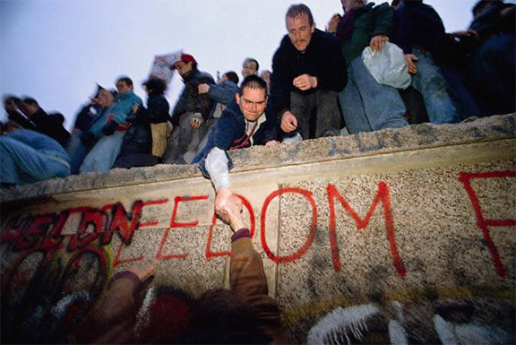
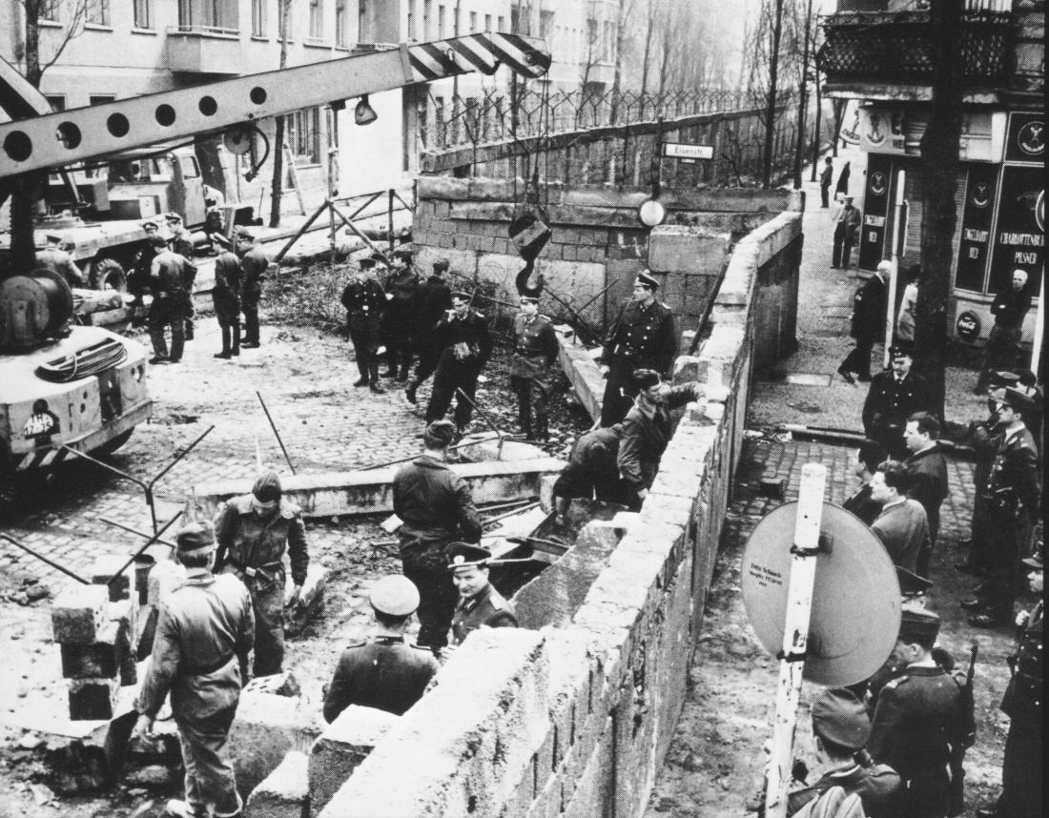

In 1963, President Kennedy visited West Berlin and made his famous 'I am a Berliner' speech next to the Berlin Wall:
There are many people in the world who really don't understand what is the great issue between the free world and the communist world - let them come to Berlin!
There are some who say in Europe and elsewhere we can work with the communists - let them come to Berlin!
All free men, wherever they may live, are citizens of Berlin. And, therefore, as a free man, I take pride in the words 'Ich bin ein Berliner' ['I am a Berliner'].
President Kennedy, 1963

